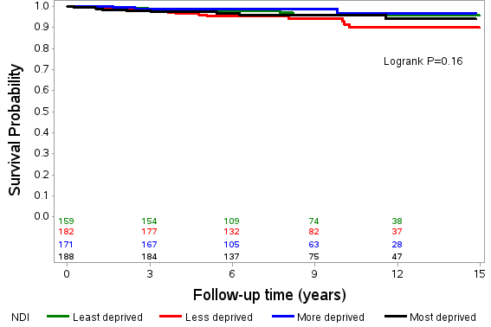
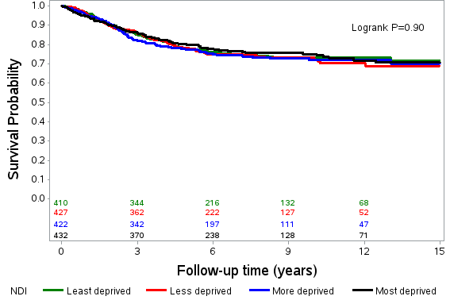
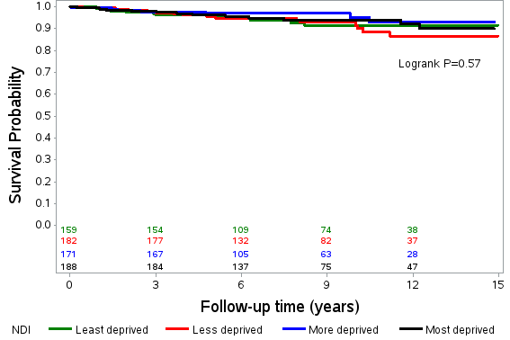
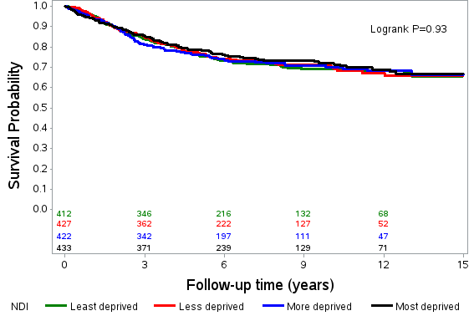
Figure 1. Kaplan-Meier survival curves for all-cause mortality and CRC-specific mortality, overall and by stage at diagnosis, by neighborhood deprivation index (NDI) quartiles.
All-cause mortality, overall
CRC-specific mortality, overall
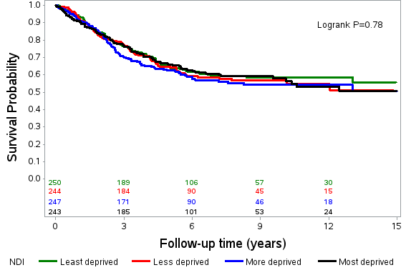
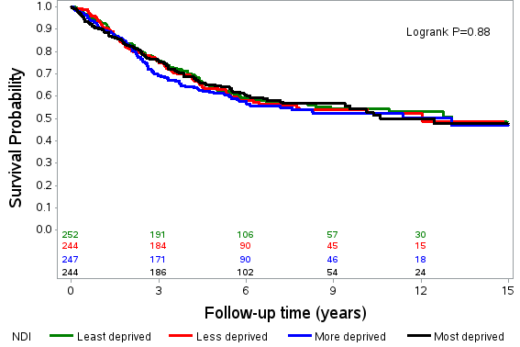
CRC-specific mortality, advanced stages
All-cause mortality, advanced stages
CRC-specific mortality, localized stage
All-cause mortality, localized stage

